# Linux Environment Variable Assignment

1. **Create a script named “myscript” in current directory to do the following.**
2. **create a dir named “subd1” in current directory**
3. **create a file named “dircontent” with contents of the current directory**
4. **display the contents of the file “dircontent”**
5. **display the contents of a non existing file named “unknownfile”**

**Ans :** vi myscripts

mkdir subd1

ls > dircontent

cat dircontent

cat unknownfile

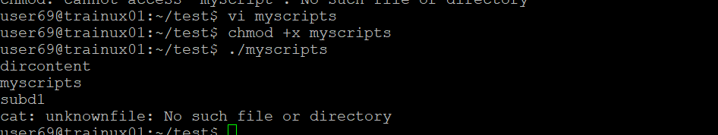

1. **Run the script and validate the output in following cases**
2. **Redirect only the stdout to an o/p file named stdout.txt**
3. **Redirect only the stderr to an o/p file named stderr.txt**
4. **Redirect both stdout and stderr to an o/p file named stdall.txt**
5. **Display all o/p and error and also redirect both stdout and stderr to an o/p file named stdall.txt**

**Ans** : ./myscript > stdout.txt

./myscript > stderr.txt

./myscript > stdall.txt > stderr.txt >& stdout.txt

./myscript > > (tee stdall.txt) > stderr.txt >& stdout.txt

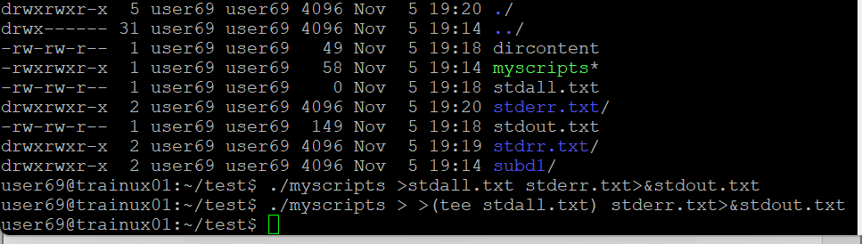

1. **Redirect the output of command below using pipe (|) to wc and get the output .**

**Ans** : ls -l / wc

